**Introduction**

**1.1 Project profile**

|  |  |
| --- | --- |
| Project Name | **GPM WELFARE NETWORK** |
| Project Objective | To provide end users (GPM Family) Online facilities like Lost & Found system, Buy & Sell Books, Search Friends, Query Forum. |
| Developed For | Government Polytechnic, Hendaj, Murtizapur |
| Developed At | Government Polytechnic, Hendaj, Murtizapur |
| Front-End | Microsoft Visual Studio 2015, c#, ASP.Net |
| Back-End | Microsoft Sql Server 2014 |
| Internal Guide | Prof. Amol S. Kulkarni |
| Developed By | Raj Umakant Patil  Sachin Ramchandra Rokade  Nikhil Ramesh Devkar  Nitin Ajay Dixit |

**1.2 About The Topic**

Normally college websites doesn’t have much facilities for students. They just have static web pages, information about college, faculties and some pictures of college and campus.

So we thought of upgrading the usual college website making practices and we came up with some new and interesting ideas of making “GPM Welfare Network” and adding facilities in it like Query Forum, Lost & Found System, Search Friends, Image Gallery for each user.

Eventually, During the semesters we faced Problems of purchasing and selling of old books. So we decided to resolve this problem by making this procedure online on our web portal which makes it easy to find the best buyers and sellers on the go.

**1.2 About The Project**

The website has been developed for our college (GPMZR) in an effort to make it as attractive and dynamic as possible. Compared to the existing site a database has been added to our project.

The working of the project is as follows.

The first page provides several links (enter button for homepage, contact etc.). The Home page contains a carousal which displays college pics, a navbar which contains all the links to different pages like about us, contact us, the developers, notice board, tender, principal’s desk, Sign In, Sign Up, RTI and all the departments of college

User Login module helps the user to login to the site. For that he must type the email and password correctly. The login provision in this page helps the already registered user to directly access the site and internal features provided for site members, there is a link for registration to a user who is new to this site.

Member Registration module helps the new user to register into the site. The information entered by the users is added into the tblUsers. After Successful registration a confirmation email is sent to the users email to activate their account. User can’t login without confirming their email, if lost then they can resend email by confirming identity (providing login password)

**Technology Overview**

* **.Net Framework**

.Net Framework is a software framework developed by Microsoft that runs primarily Microsoft windows. It includes a large class library named Framework Class Library (FCL) and provides language interoperability across several programming language. Programs written for .Net Framework executes in a software environment named Common Language Runtime (CLR), an application virtual machine that provides services such as security, memory management, and exception handling . FCL and CLR together constitute .Net Framework.

* **Microsoft Visual Studio 2015**

Microsoft Visual Studio is an Integrated Development Environment (IDE) from Microsoft. It is used to developed computer programs, as well as websites, web apps, web service and mobile apps. Visual Studio use Microsoft software development platforms such as Window API, Windows Forms, Windows Presentation Foundation, Windows Store and Microsoft Silver lite. It can produce both native code and managed code.

* **Features of Microsoft Visual Studio 2015**

The Visual Studio 2015 preview included many new features that enhanced the way developed work with everything from the web and desktop to mobile apps.

Some of the features of MS2015 are:

1. Custom Windows Layouts

This feature comes in handy if you develop on multiple devices. Say for example that you use a Surface Pro to develop on your train ride home and a 23″ monitor during the day. You can quickly switch between devices by going to Window -> Apply Window Layout and selecting one that you created earlier.

1. Better Code Editor

The code editor has been replaced with “Roslyn” to give you a new and improved code editing experience. Light bulbs are shown when you need to include fixes to your code or refactor it. Whenever you see a light bulb appear, then click it and it will give you suggestions based upon the code it has analyzed.

1. IntelliSense

Due to IntelliSense coding has become easier and faster. The programmer need not use to remember all the method names and their signature type at once, he just have to type 2 or 3 words of the method name and simply press ctrl+space bar, after pressing it the method with the signature type will be printed on screen. It results in reducing time for writing code.

1. Sign in across multiple accounts

With Visual Studio 2015, the new streamlined sign-in experience is designed to greatly simplify your access to online resources, even when you have multiple Visual Studio accounts. After you sign-in to Visual Studio, you are automatically signed in to all instances of Visual Studio 2015 and Blend on your machine. Signing in automatically starts roaming your settings for you.

* **ASP.NET 5**

ASP.NET 5 is an open source web framework for building modern web applications that can be developed and run on Windows, Linux and the Mac. It includes the MVC 6 framework, which now combines the features of MVC and Web API into a single web programming framework.  ASP.NET 5 will also be the basis for Signal R 3 - enabling you to add real time functionality to cloud connected applications. ASP.NET 5 is built on the .NET Core runtime, but it can also be run on the full .NET Framework for maximum compatibility.

With ASP.NET 5 you gain the following foundational improvements:

* Build and run cross-platform ASP.NET apps on Windows, Mac and Linux
* Built on .NET Core, which supports true side-by-side app versioning
* New tooling that simplifies modern Web development
* Single aligned web stack for Web UI and Web APIs
* Cloud-ready environment-based configuration
* Integrated support for creating and using NuGet packages
* Built-in support for dependency injection
* Ability to host on IIS or self-host in your own process

* **C# - Front-End**
* C# is an Object Oriented language and does not offer global variables or functions. Everything is wrapped in classes, even simple types like int and string, which inherits from the System.Object class.
* C# can be written with any text editor, like Windows Notepad, and then compiled with the C# Command line compiler, csc.exe, which comes with the .NET framework. However, most people prefer to use an IDE (Integrated Development Environment), and Microsoft offers several options for this. Their flagship is Visual Studio, which can be used to work on every possible aspect of the .NET framework. This product is very advanced, and comes in several editions. Visual Studio is not exactly cheap, and might even be too advanced for hobby programmers.
* With .NET framework 2.0, Microsoft introduced the so-called Express versions, targeted at hobby programmers and people wanting to try .NET, and they continued this tradition with the later release of .NET 3.0 and 3.5. The Express versions only work for one language, like C# or VB.NET, and miss some of the really advanced features of Visual Studio.
* **Bootstrap 4**
* **What is Bootstrap?**
* Bootstrap is a free front-end framework for faster and easier web development
* Bootstrap includes HTML and CSS based design templates for typography, forms, buttons, tables, navigation, modals, image carousels and many other, as well as optional JavaScript plugins
* Bootstrap also gives you the ability to easily create responsive designs

## Why Use Bootstrap 4?

Advantages of Bootstrap 4:

* **Easy to use:** Anybody with just basic knowledge of HTML and CSS can start using Bootstrap 4
* **Responsive features:** Bootstrap's responsive CSS adjusts to phones, tablets, and desktops
* **Mobile-first approach:** In Bootstrap 4, mobile-first styles are part of the core framework
* **Browser compatibility:** Bootstrap 4 is compatible with all modern browsers (Chrome, Firefox, Internet Explorer 10+, Safari, and Opera)

## Where to Get Bootstrap 4?

There are two ways to start using Bootstrap 4 on your own web site.

You can:

1. Include Bootstrap 4 from a CDN
2. Download Bootstrap 4 from getbootstrap.com

* **SQL SERVER 2014 – Back-End**
* **Microsoft SQL Server** is a [relational database management system](https://en.wikipedia.org/wiki/Relational_database_management_system) developed by [Microsoft](https://en.wikipedia.org/wiki/Microsoft). As a [database server](https://en.wikipedia.org/wiki/Database_server), it is a [software product](https://en.wikipedia.org/wiki/Software_product) with the primary function of storing and retrieving data as requested by other [software applications](https://en.wikipedia.org/wiki/Software_application)—which may run either on the same computer or on another computer across a network (including the Internet).
* Microsoft markets at least a dozen different editions of Microsoft SQL Server, aimed at different audiences and for workloads ranging from small single-machine applications to large Internet-facing applications with many [concurrent users](https://en.wikipedia.org/wiki/Concurrent_user).
* **Features of SQL SERVER 2014**

### In-Memory OLTP Engine

### SQL Server 2014 enables memory optimization of selected tables and stored procedures. The In-Memory OLTP engine is designed for high concurrency and uses a new optimistic concurrency control  mechanism to eliminate locking delays. Microsoft states that customers can expect performance to be up to 20 times better than with SQL Server 2012 when using this new feature.

### Buffer Pool Extension

### SQL Server 2014 provides a new solid state disk (SSD) integration capability that lets you use SSDs to expand the SQL Server 2014 Buffer Pool as nonvolatile RAM (NvRAM). With the new Buffer Pool Extensions feature, you can use SSD drives to expand the buffer pool in systems that have maxed out their memory. Buffer Pool Extensions can provide performance gains for read-heavy OLTP workloads.

### Storage I/O control

### The Resource Governor lets you limit the amount of CPU and memory that a given workload can consume. SQL Server 2014 extends the reach of the Resource Governor to manage storage I/O usage as well. The SQL Server 2014 Resource Governor can limit the physical I/Os issued for user threads in a given resource pool.

### Backup Encryption

### One welcome addition to SQL Server 2014 is the ability to encrypt database backups for at-rest data protection. SQL Server 2014 supports several encryption algorithms, including Advanced Encryption Standard (AES) 128, AES 192, AES 256, and Triple DES. You must use a certificate or an asymmetric key to perform encryption for SQL Server 2014 backups.

* **ADO.NET**
* Database is a data structure used to store organize information.
* It is a collection by records or data .
* A is typically made up many linked table of rows and columns.
* **ADO.NET ARCHITECTURE**
* The ADO.net is new database technology of .net platform.
* It builds on Microsoft Active & Data object (ADO).
* The ADO .net is a set of classes that expose data access services to .net developer.
* **This architecture can be divided into two logical pieces** :
* **Command Execution**
* It needs Connectivity, Execution and Reading of result.
* Such features are enable with .Net Data provider.
* **Cache**
* The Data Set handles caching of result.
* **ADO.NET Architecture**

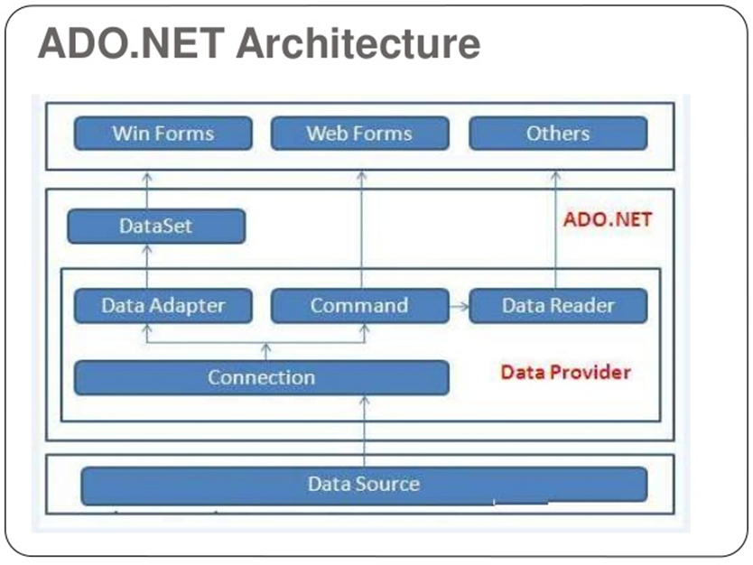

* **Waterfall Model**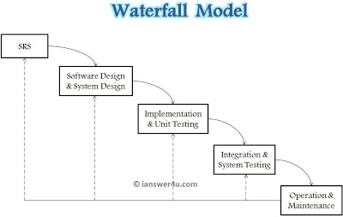
* **Incremental Model**

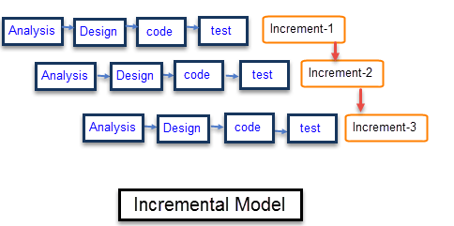

* **RAD MODEL**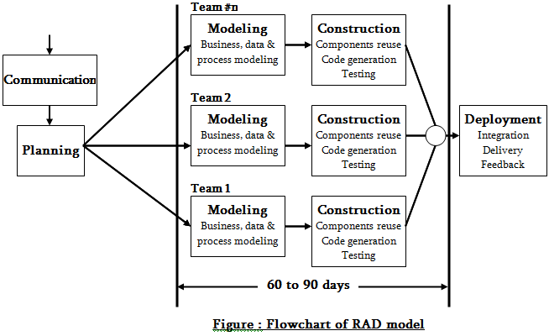
* **Agile Model**

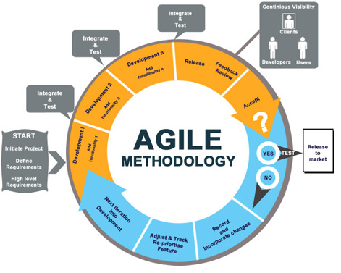

**SYSTEM ANALYSIS AND DESIGN**

3.1 INTRODUCTION

System analysis is the process of gathering and interpreting facts, diagnosing problems and using the information to recommend improvements on the system. System analysis is a problem solving activity that requires intensive communication between the system users and system developers.

3.2 EXISTING SYSTEM

The existing college website is static which makes it less interactive. It doesn't have a database connectivity. Moreover students didn't have an access to the details of the college through the site, hence they were not updated about the latest notices.

3.3 PROPOSED SYSTEM

In order to make the site dynamic and more interactive we have added different functionalities and features through different modules like Faculty Feedback system, Lost & Found System, Buy & Sell books, Search Friends, Dynamic Notice board, Query Forum, Library module.

Hence, it makes it more dynamic when it comes to adding, deleting and editing notices, tenders etc. In response to which students can submit their willingness to appear for the drive along with his personal details. Provision has also been made to display the latest events and announcements associated with the college online. We have developed our project using the three tier architecture which uses the following languages.

**3.3 SOFTWARE REQUIREMENTS**

|  |  |
| --- | --- |
| OPERATING SYSTEM | : WINDOWS 7/8/10 |
| BROWSER | :CHROME OR ANY HTTP BROWSER |
| FRONT END | : ASP.NET |
| DATABASE LAYER | : SQL SERVER 2014 : IIS |
| WEB SERVER | : C#.NET |

**3.4 HARDWARE REQUIREMENTS**

|  |  |
| --- | --- |
| PROCESSOR | : i3 |
| CLOCK SPEED | : 2.5 GHZ |
| SYSTEM BUS | : 64 BIT |
| RAM | : 4 GB |
| HDD | : 40GB |

**SYSTEM DESIGN**

System design is the solution to the creation of a new system. This phase is composed of several systems. This phase focuses on the detailed implementation of the feasible system. It emphasis on translating design specifications to performance specification. System design has two phases of development logical and physical design.

During logical design phase the analyst describes inputs (sources), out puts (destinations), databases (data sores) and procedures (data flows) all in a format that meats the uses requirements. The analyst also specifies the user needs and at a level that virtually determines the information flow into and out of the system and the data resources. Here the logical design is done through data flow diagrams and database design.

The physical design is followed by physical design or coding. Physical design produces the working system by defining the design specifications, which tell the programmers exactly what the candidate system must do. The programmers write the necessary programs that accept input from the user, perform necessary processing on accepted data through call and produce the required report on a hard copy or display it on the screen.

**WORKING METHODOLOGY**

**Module Wise Description :**

* **Different Users of 'GPM Welfare Network' :**

1. Main Admin
2. Library Admin
3. End Users (students)
4. Visitors

* The Above Users have modules like :

1. Main Admin Module

2. Library Admin module

3. End Users (students) module

4. Visitor module

* The visitor module includes,
* Visitor Can be able to see the home page of the 'GPM Welfare Network'.
* Visitor can see Department details, Notice board, Pricipal’s profile, About Us, The developers, Tenders, RTI, and Contact us details.
* Each User above shares Login Module :-
* **Login module :-**

The 'GPM Welfare Network' Login module is secured and user friendly module which only gives access to authorized users. Which have their account registered and as well as their E-mail confirmed. The login module is used to check whether the user is an authorized person to use the system or not. For this the user should provide valid email and password. Generally, user forget their usernames of different websites. Therefore, we login using users email which they easily remember.

There is a 'remember me' checkbox provided. Using this users can save the email and password in their local machines as a cache for around 10 days. Using this they don't have to type email and password again and again.

The login attempt is successful only when the user is authorize and has confirmed their e-mail. If the user has not yet confirmed their e-mail through their respective e-mail account then they are redirected to 'UserNotActivated' page which displays user not activated message alert.

If user has not received an email of account confirmation then they can resend the account activation link from that page just by confirming their identity by providing respectivepassword. Then again an account activation link is send to users e-mail. Then they have to open that link in order to activate their account.

* **The different types of users are :**

1. Main Admin

2. Library Admin

3. Users (students)

* The End User (students) module includes :

1. Registration module (Sign Up)
2. Forgot Password module
3. Library Module
4. Faculty Feedback Module
5. Edit User Profile module
6. Change Password module
7. Lost and Found module
8. Buy and Sell Book module
9. Query Forum module
10. Search Friends module
11. **Registration module (Sign Up)** :-

The 'GPM Welfare Network' Registration module is purely for students and is easily understandable. The registration includes details to be filled like First name, Last name, Username, Email (active), Enrollment No., Mobile No., Current Year, Current Semester, Uploading a profile pic, Password And Confirm Password.

All fields in the registration form are mandatory. The Password should be equal to or more than 4 characters and Profile Pic should not be more than 5mb.

For the sake of unicity, we have applied live checking of Username and Email using javascript ajax. So that User don’t get frustrated after filling the whole form and after submitting gets an error saying “username is taken” or “email is already registered”.

Every account in The 'GPM Welfare Network' is unique in accordance with the unique username and Email. The 'GPM Welfare Network' maintains privacy like all the Passwords of Users are hashed Passwords by using SHA1 algorithm which is present in C# and can’t be decrypted easily.

For the sake of storage, all the Images like Profile Pictures and User Gallery Images are first Converted Into Binary and then stored in database table tblImages and dbo.Imagedata respectively.

**2. Forgot password module :-**

If in case any user forgets their password they can reset it using 'forgot password' utility provided as a link in the login page beside the 'remember me' option. When the user clicks the 'forgot password' link they are redirected to a page asking for their E-mail.

If the e-mail entered by user matches the one in database then a password reset E-mail is sent to the specified e-mail of user. The password reset e-mail contains a link with unique GUID to identify user as it is previously stored in db in tblForgotPassRequest containing user id and GUID.

Once the user clicks the password reset e-mail by using their respective e-mail account then they are redirected to a password reset form where they can reset their password by providing a new password and confirmation password. Once they do it, they are all set to login easily with their new password.

**3. Library Module :-**

The Students Library module is Simple and attractive module which shows the list of all the available books in the library of the department to which the user belongs. The books list shows the Book name, Author name, Price, Publication.

User can search the Books in the list just by entering the book name in the search box and clicking the search button. The search box works like the characters contained in the search box matches the book name in the list whether it be the initials or full name.

If the User searches the empty search box then all the list of available books is shown. The default maximum no. of rows in the single page is 10. Other books are available in next page. The user can see them by clicking the next page number below the list. And it also displays message like “Displaying Page 1 of 2” to show the total page.

**4. Faculty Feedback Module :-**

Faculty Feedback module contains a Feedback page for students to fill up for giving a feedback of Faculties. This Feedback is then stored in database tables like tblCompFeedback, tblITFeedback, tblMechFeedback, tblElecFeedback.

The User can only give Feedback to the Faculties belonging to their departments. They can select the Faculty name by using a dropdown list. Users have to fill details like their name and answer the questions which have radio button options. The questions like :-

1. Knowledge of the teacher on the subject
2. Clarity and understanding of teacher's explaination
3. Approximate percentage of classes not engaged by the teacher in the subject
4. Behaviour of the teacher
5. Overall teaching effectiveness of the teacher

And at the last they have the option to fill any other relevant information about the Faculty (suggestions, some queries etc.)

**5. Edit User Profile module:-**

The Edit User Profile Module comes so handy when member (students / user) of ‘GPM Welfare Network’ wants to edit their first name, last name and even username and Profile Picture.

The Edit User Profile module again has some validation and restriction like all fields are mandatory and should not be empty. Here, the user can change their First name, Last name.

We have again applied live checking of Username by using javascript ajax so that User doesn’t chooses the already available username in the database which causes duplicate entry of username and causes ambiguity in further coding logics.

Users can change their profile pictures by uploading another picture via File Upload. Notice that the message has been displayed at the top that profile pic should not be more than 5mb. Therefore, Profile Pic more than 5mb can’t be uploaded.

And for security reasons we have allowed only .jpg, .bmp, .png extension file only so that any bad user doesn’t upload any virus or something like that. In order to change the profile pic or name or username one needs to confirm their password and then click on save button. If all the validations are met then changes are good to go. And finally you can see the changes after that.

**6. Change Password module:-**

If any User wishes to Change their password then they can do it easily by using change password facility. They just have to provide the current password and then a new password and confirmation password.

Here also all fields are mandatory. The new password should be equal to or more than 4 characters.

If the current password is correct and the new and Password and Confirmation Password matches then the passwords are successfully changes by clicking the change password button.

**7. Lost & Found module:-**

Lost and Found Module is essential module in GPM Welfare Network which will indirectly help to students for finding items, in case of losing object of end user. The Lost and Found Module includes 1. Lost & Found Item Registration

**Lost Items**

1. Founded Items, Helper’s Requests. Lost And Found System Contain two sections –The first one is LOST Section and another one is FOUND Section.
2. **Lost Section:-**

In Complaint Registration form victim registers his complaint by filling necessary information in it. Now the complaint will be registered and it will show up on “Lost Items” Page of module to each and every users in GPM Welfare Network. On “Lost Items” Page below the description of each complaint there is a ‘Contact’ button. If any end user (Student) knows something about the victim’s lost item, they should click on Contact Button and try to communicate or help by sending message. So Because of that, there should be most of chance of finding victim’s item.

After replying a particular complaint in “Lost Items” web page the victim receive a request from helper which is none another than end user in GPM Welfare Network. Received request contain necessary information about helper and message for lost item .It has two button at bottom end of request that is:-i. DELETE ii. FOUND. When victim want to delete received request send by anonymous helper then they simply click on Delete option which is present at bottom end of Request Panel. In that way, only request send by particular helper will be deleted and the complaint will be remain same show up on “LOST ITEMS” page.

But if they founded an item by receiving request and by communication with helper and so they want to be remove complaint from Lost Item page. For that purpose we provide another button called FOUND button .when victim click this button the complaint from “LOST ITEMS” as well as request panel which was only seen by victim are permanently deleted.

1. **Found Section:-** In this section end user helps anonymous victim if they found something in the GPM premises by giving details about Founded items . For that purpose we provide a “Found Something? Tell us” form. Inside that form end user fills detail information about item which was founded by them.

After submitting that form, the help will show up on “Founded Items” page of module to each and every users in GPM Welfare Network. Inside this page there are table of rows and Columns where the data of founded items are shows up. It also have a search bar where end user easily search items by entering Item name.

**8. Buy & Sell Books module:-**

Buy and Sell Books module is essential module in ‘GPM Welfare Network’ which will help the student in purchasing and selling old semester Books. The buy and Sell book module includes Four Pages which are listed below:

1. Sell Book

2. My selling Request

3. Buy Book

4. Request

In “Sell Book” page Seller puts his request by filling necessary information about the book like its name, amount etc. Now each request will show up on “BuyBook.aspx” to every user in GPM welfare Network. And for the seller it will show up in “My selling request” page.

In “My selling Request” seller is able to delete his selling request. If seller deletes his request from “my selling request “page, corresponding request from “Buy Book” will be deleted.

In Buy Book page each request will be show up with a description of each request and with a Contact Button .If any student or buyer want to buy a book , then they should Click on contact Button to contact with a seller by sending a request with his information such as email, mobile no ,and additional message.

If any Buyer send a request for purchasing a book then it will show up in “Request” page of seller with a buyer information and also email will be send to seller. Form Request page seller is able to delete buyer request either confirm his request. If seller delete his request from request page then it will be deleted from Request page and an email will be sent to buyer with contact details of seller. And if seller confirm his request from request page the particular request will be deleted from request page and also from Buy book page. And confirmation email will be sent to buyer.

**9. Query Forum module:-**

Query forum is also most essential module for every students in GPM family. It will help the student in finding out correct answer. This module is divide into two sections, ‘Question’ section and ‘Answer’ section. Question.aspx contains the functionality for uploading a Questions on Query Forum. Question.aspx show up all question in a list with a ‘reply’ button. If any student click on ‘reply’ button then he/she will be redirected to Answer.aspx. Here the student can write his/her answer and post it. Query forum also provides searching facility in which student can search desired questions which are asked by another student.

* **The Main Admin Module includes :**

1. Dashboard Module
2. Manage Module
3. View Module

**1.DashboardModule:** The Dashboard module is a simple module which provides the admin with some user related Information like total number of Users registered in the site. Total number of male Users, Total numbers of Female Users and Total numbers of Other Users according to the gender column in tblUsers in database.

This is just like stats of registered Users according to gender. In Future we would try to show number of visitors and other such informations.

**2. Manage Module :**

The Manage Module includes sub-modules like :

1. Managing Notice Board
2. Managing Tenders
3. Managing Tables

**1. Managing Notice Board includes :**

1. **Add Notice :**

The Add Notice sub-module helps to add notice in tblNoticeBoard dynamically in the database.

The Admin just has to provide Notice Title, Notice Subject and Notice Description in the respective textboxes and then click the submit button.

They are then instantly added below in the list with the timestamp. All the notice displaying in the list below are displayed on the notice board page which a visitor can see too. This way we make it dynamic and easy.

1. **Edit Notice :**

In Case if Admin wishes to edit the Notice title, subject description or even wants to delete the notice all together then Edit Notice comes handy. Admin can change the Notice title, Notice subject and Description just by clicking on edit button.

Then it open an edit panel where admin can edit them. All fields are mandatory as always.

Admin can’t change the timestamp of a notice. If admin wishes to delete a particular notice then he/she can just by clicking on delete button.

After that a confirmation dialogue box appears with the help of js which says “are you sure you want to delete this entry? This can’t be undone.” If the Admin clicks ok then the entry is deleted otherwise not if admin clicks cancel.

**2. Managing Tenders Includes :**

1. **Add Tender :**

The Add Tender sub-module helps to add Tender in tblTender dynamically in the database.

The Admin just has to provide Tender title and tender link in the respective textboxes and then click the submit button.

They are then instantly added below in the list with the posted date. All the Tenders displaying in the list below are displayed on the Tenders page which a visitor can see too. This way we make it dynamic and easy.

1. **Edit Tender :**

In Case if Admin wishes to edit Tender title and tender link or even wants to delete the Tender all together then Edit Tender comes handy. Admin can change the Tender title and tender link just by clicking on edit button.

Then it open an edit panel where admin can edit them. All fields are mandatory as always.

Admin can’t change the posted date of a Tender. If admin wishes to delete a particular Tender then he/she can just by clicking on delete button.

After that a confirmation dialogue box appears with the help of js which says “are you sure you want to delete this entry? This can’t be undone.” If the Admin clicks ok then the entry is deleted otherwise not if admin clicks cancel.

**2. Managing Tables includes :**

1. tblCompFaculty

2. tblITFacultly

3. tblMechFaculty

4. tblElecFaculty

Above mentioned all the tables can be manged by admin in mange > tables sub-module. Here, the list of all the faculties belonging to specific departments are managed. Here, Admin can insert any new faculty, delete any existing faculty entry, edit any faculty entry like their name and email.

**1.View Module :**

The View Module includes sub-modules like :

1. Feedback view
2. User database view

**1.Feedback view:**

Here, the admin can see all the feedback provided by end users (students). The feedback are arranged and stored according to the departments to which a faculty belongs. Admin can even search the specific faculty’s feedback by entering name of faculty in search box and clicking the search button. It will then filter the list of all the feedbacks and will show the specified faculty’s feedback. Admin can even delete the feedbacks just by clicking on the delete button.

After that a confirmation dialogue box appears with the help of js which says “are you sure you want to delete this entry? This can’t be undone.” If the Admin clicks ok then the entry is deleted otherwise not if admin clicks cancel.

**1.User database view:**

Here, the admin can see all the registered members (students) of ‘GPM Welfare Network’ and all their information. Admin has the delete right too to delete a user from the database.

**SCHEDULING OF OUR PROJECT**

We had started our project journey at the last of 4th semester, around in a month of September. Firstly we had discussed about what to implement, and then at the last we decided to make a college web portal which is a college website that will be friendly for the students. Then we had thought about the modules for our website. At first we had decided to make 4 modules but after we had started implementing our project some new modules were also added for the welfare of GPM’s students.

Then the time came for deciding the title for the project. We thought, as we are implementing this project for the welfare of GPM Family then why shouldn’t we keep **“GPM Welfare Network”** as our project title. Thus we choose this as our project title.

**TESTING**

For testing we have adopted the build and test methodology. We used to test the modules manually like when one of our team members completed implementing his module then remaining used to test that module. We have used incremental model in our software development process as our requirements were going on increasing while implementing the project.All members coordinated and tested each other’s modules.

**Role and Responsibility**

For Creating GPM Welfare Network in our team each & every member did many different activities. For planning the design & necessary activities in group **Nikhil R. Devakar** played a standard role. To plan the activities which are essential for us, then at that time we all gathered together and decided & took important decisions. In our team for creating the modules of GpmWelfareNetwork we had unique ideas and different knowledge that’s why we all member performed Designing and Coding as per our module and each member tested the modules developed by other one.

Similarly to Design and Developing the various module in our project **Sachin R. Rokade** , **Nitin A. Dixit** , **Raj U. Patil** played an essential role. In our team, when any one faced problems related to developing module each member shared his programing knowledge and suggestions.

**Statistical Info**

|  |  |
| --- | --- |
| Total number of .aspx pages | 54 |
| Total number of master pages | 4 |
| Total number of css files | 12 |
| Bootsrap version used | 4.0 |

**Results and Discussion**

**Landing page**

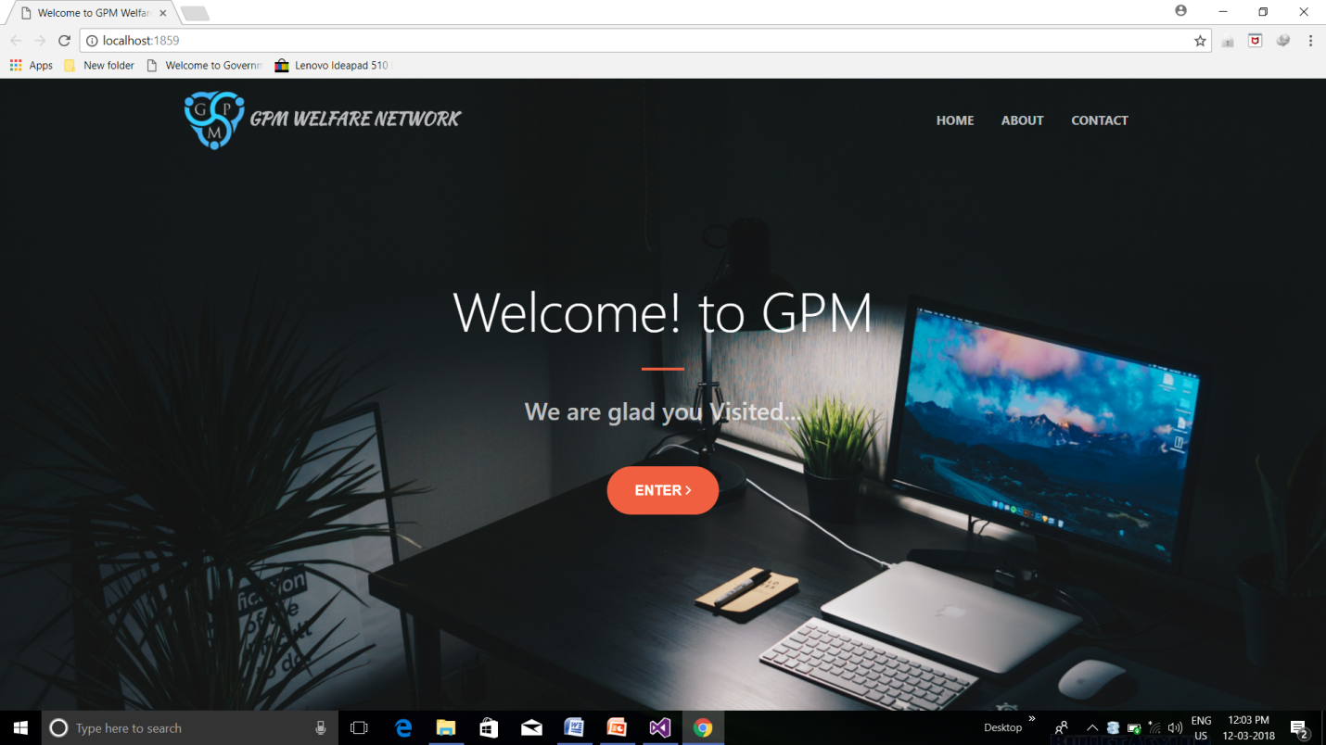

**Home Page** 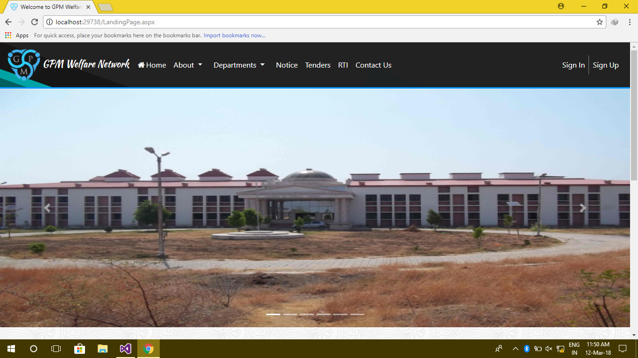

Types Of USER

Main admin :

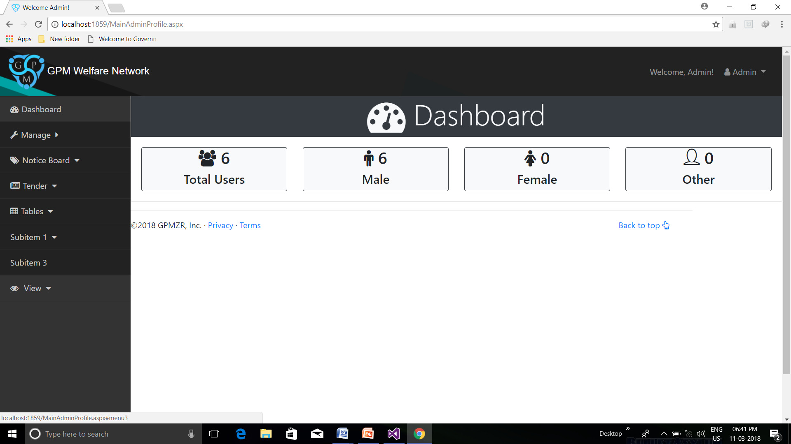

End User :

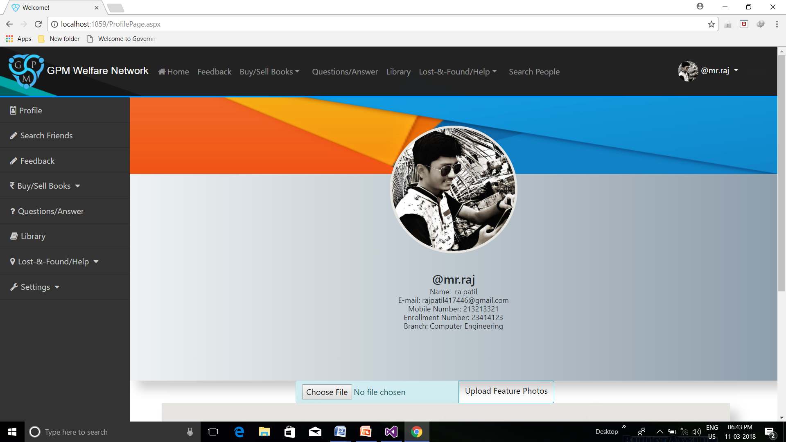

Library Admin:

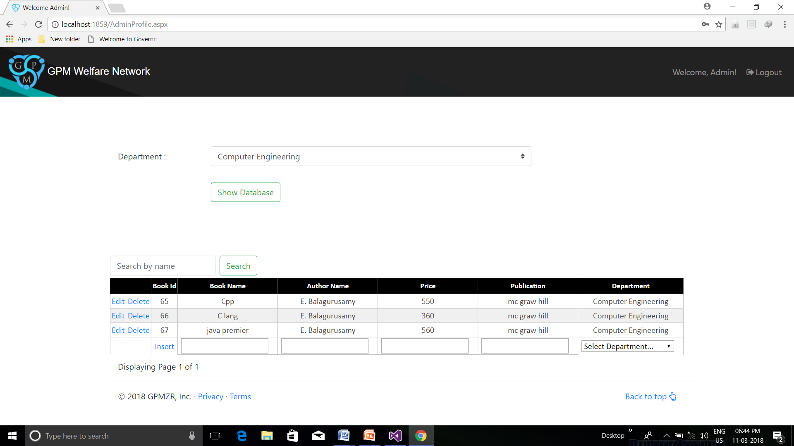

**Login Module**

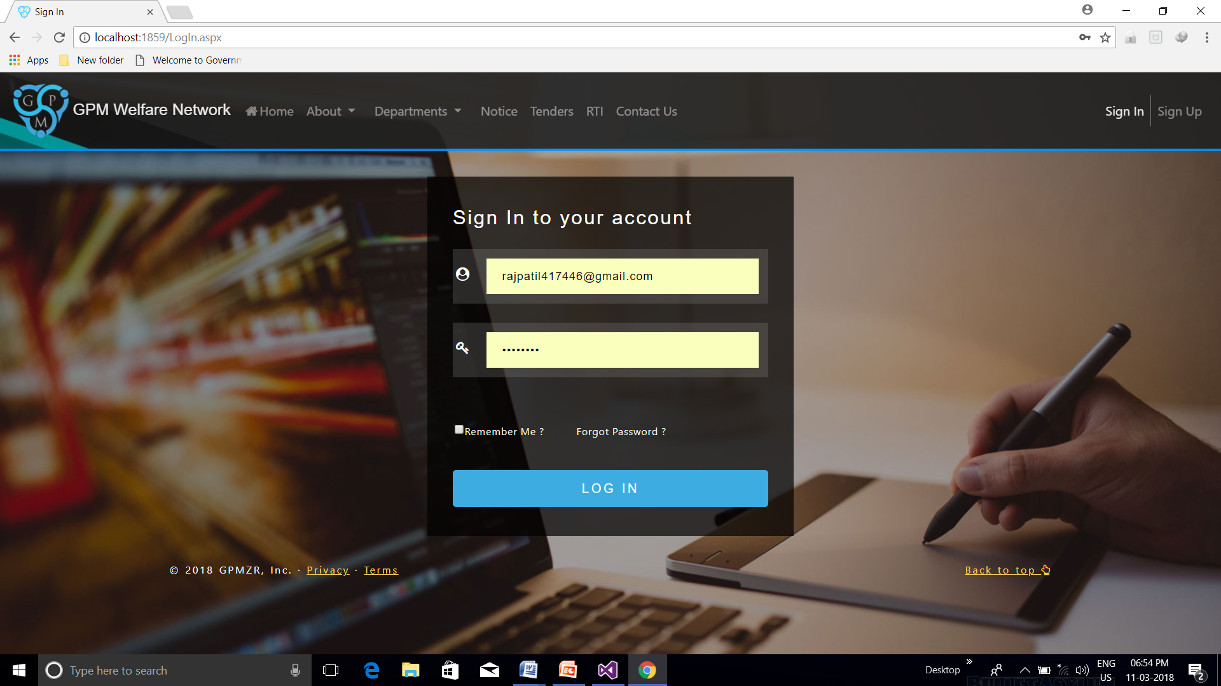

**Registration Module**

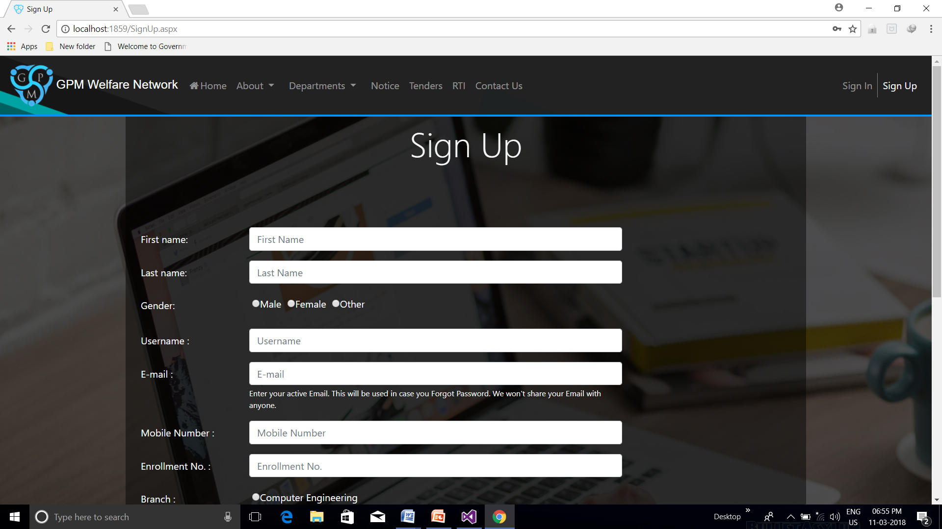

**Lost And Found Module**

**Lost and found Registration**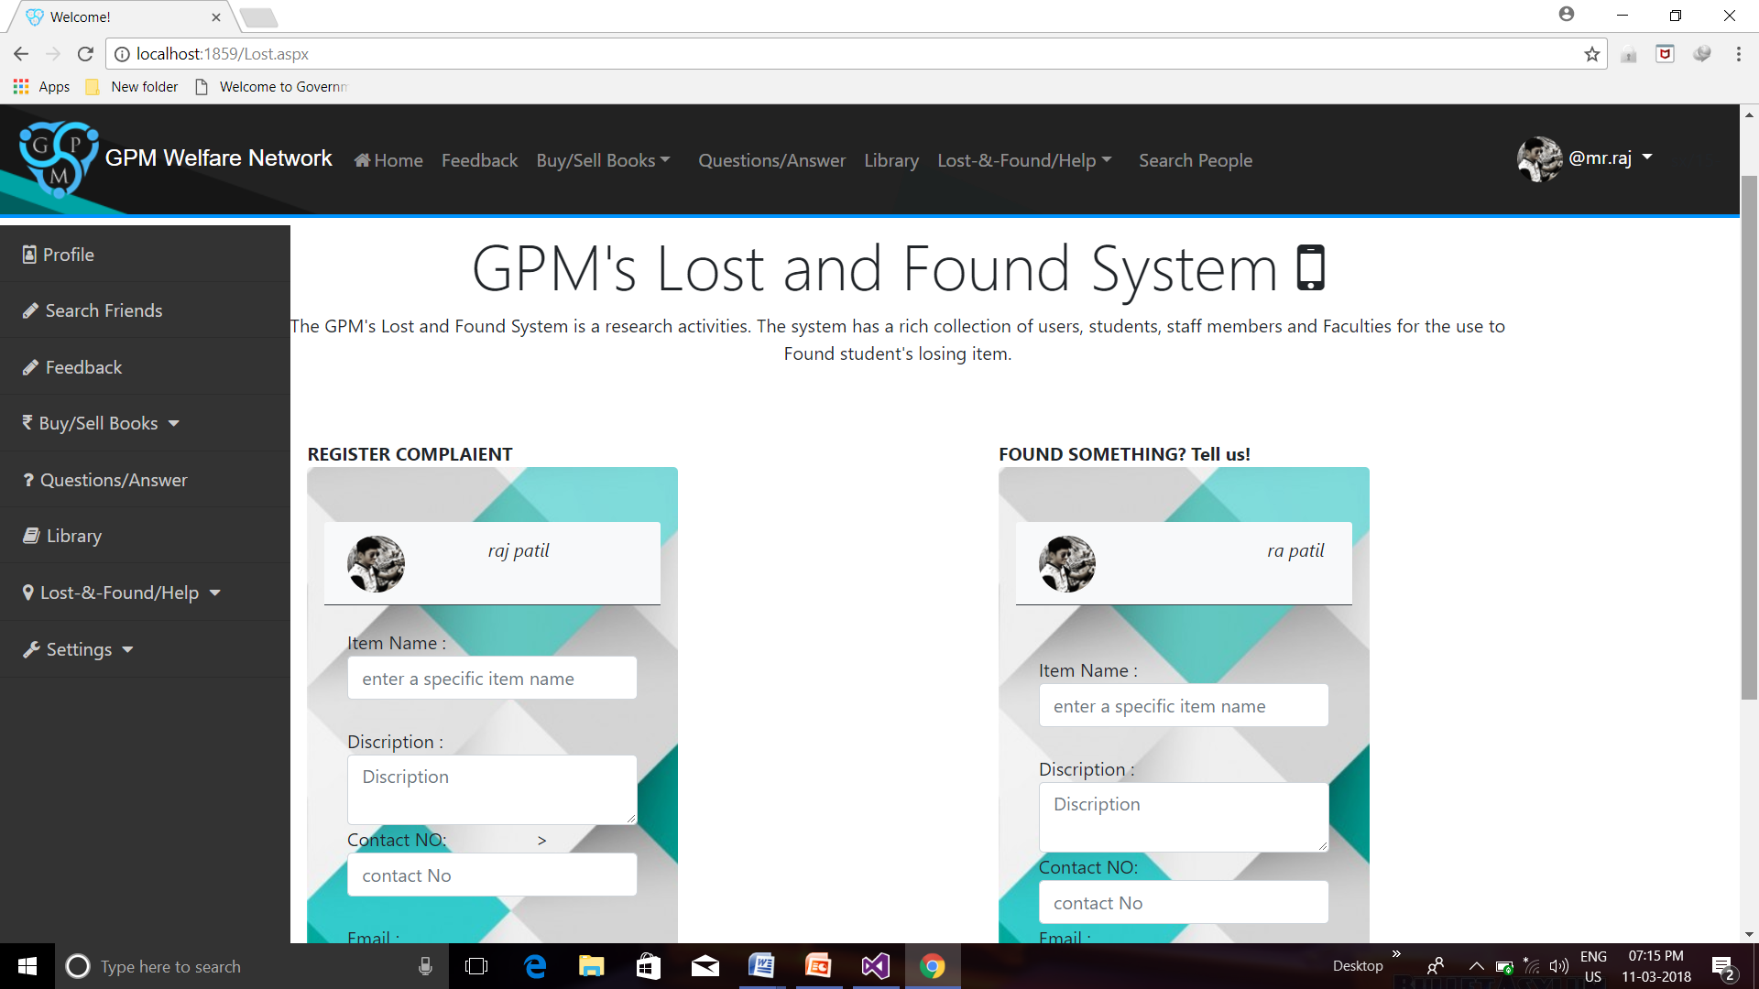

**Lost items**

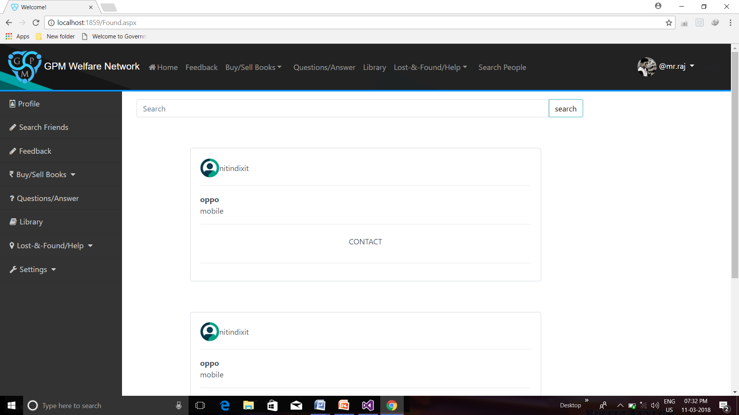**My lost items**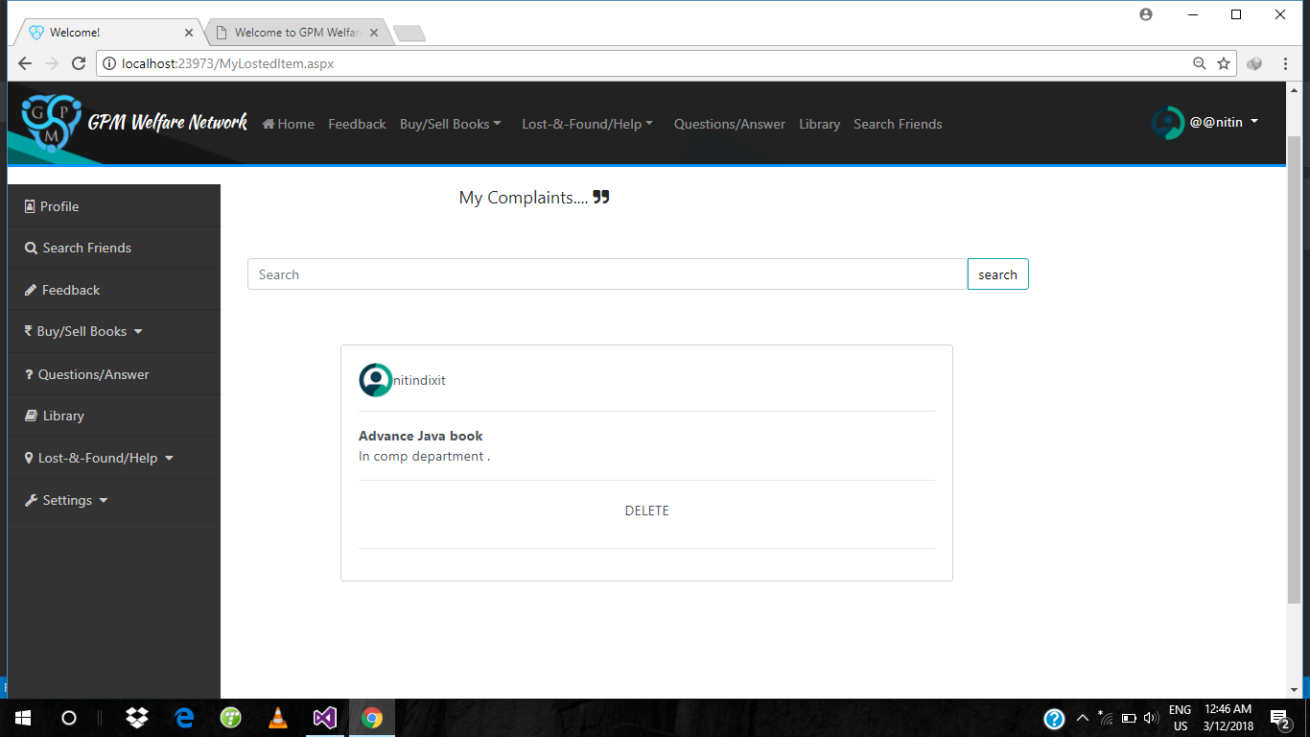

**Founded items**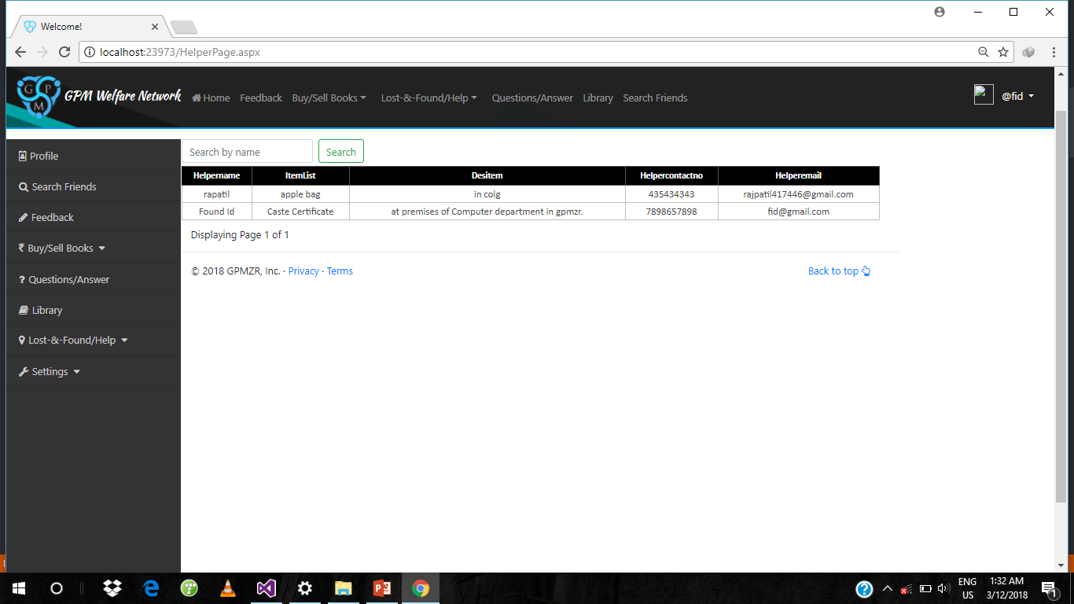

**Contact page**

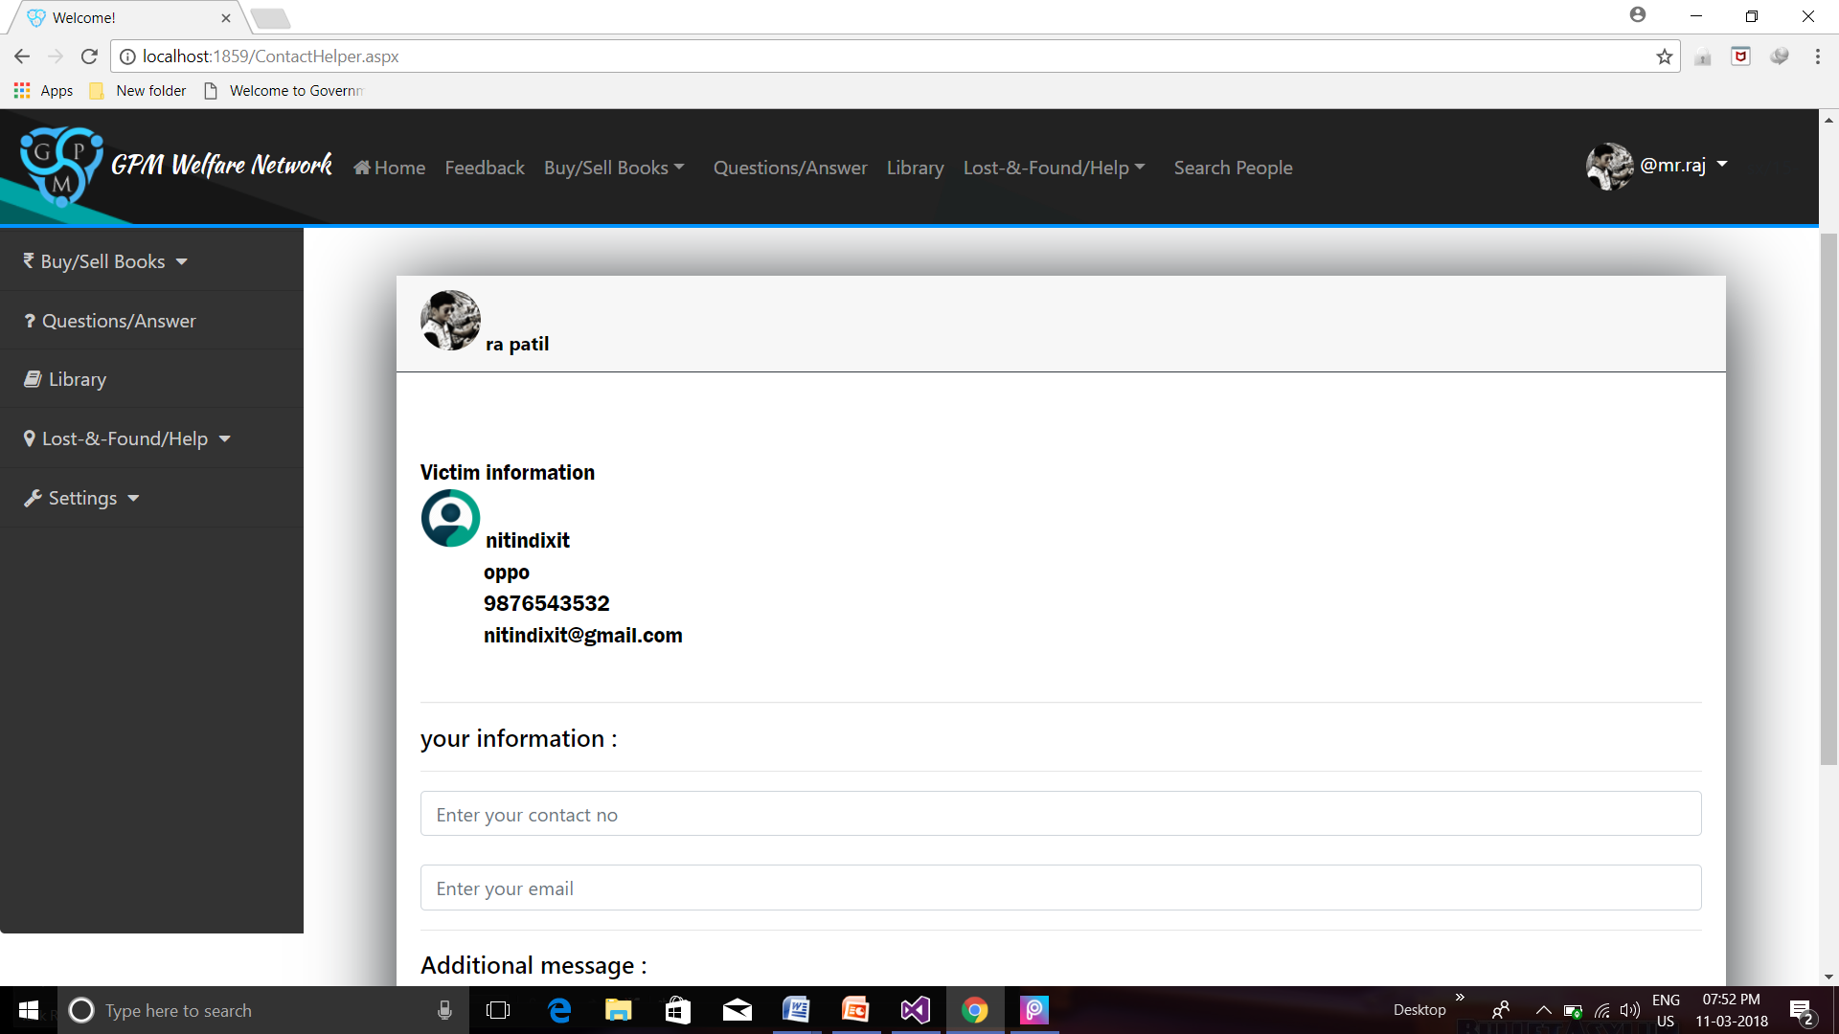

**Helper’s Request**

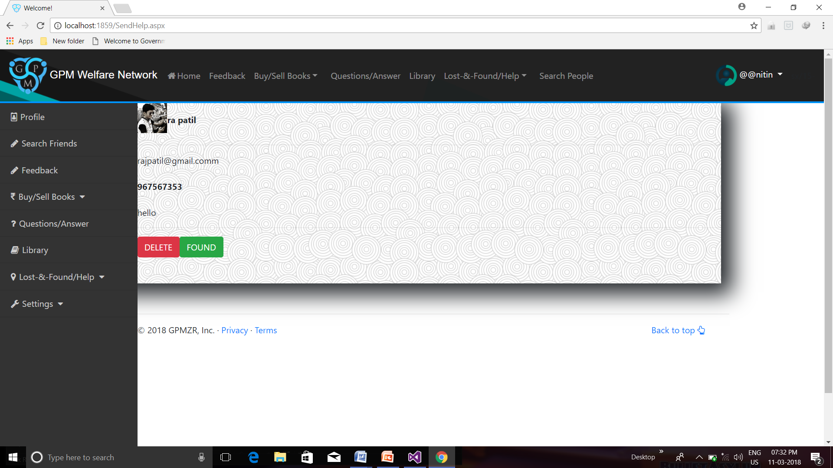

**Buy And Sell Book module**

**Sell Book**

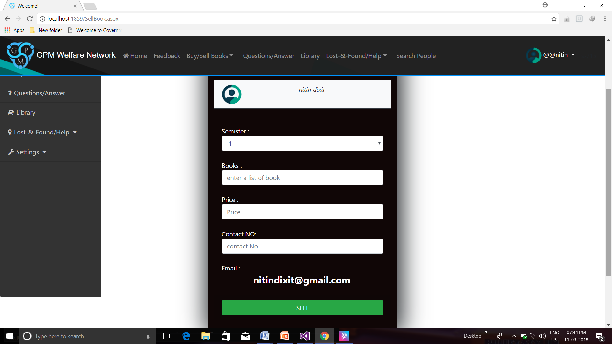

**Buy Book**

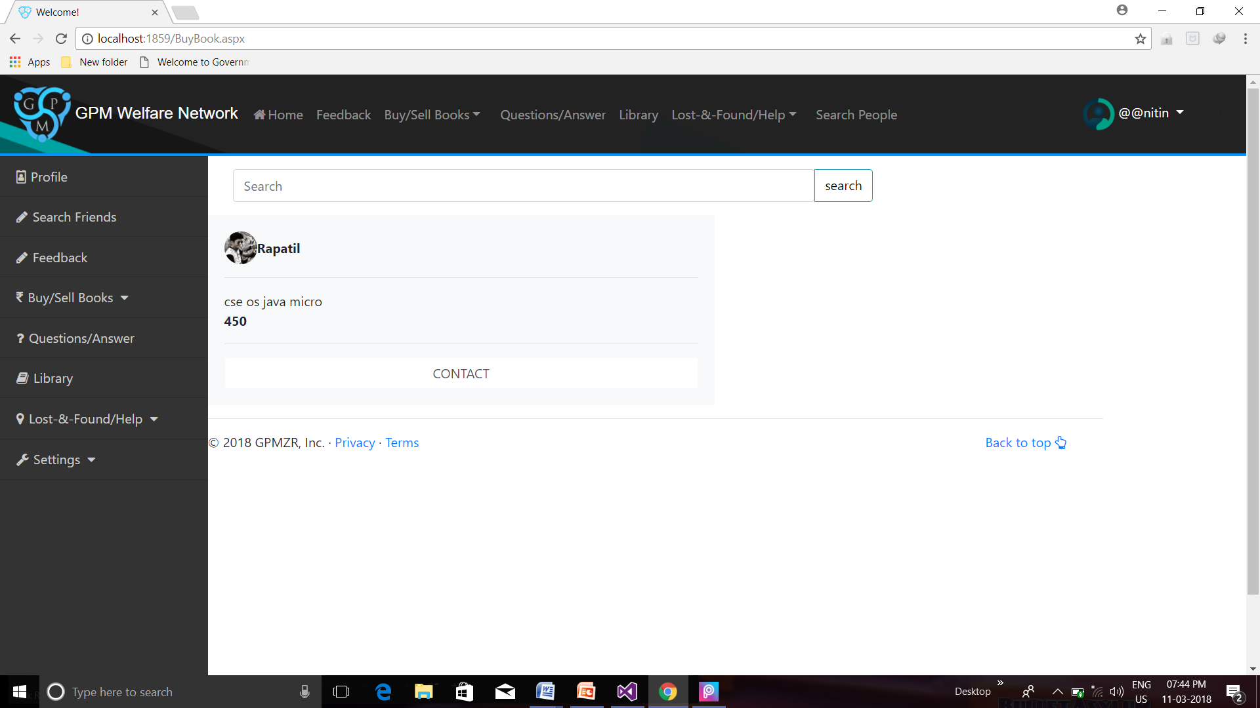

**Contact page**

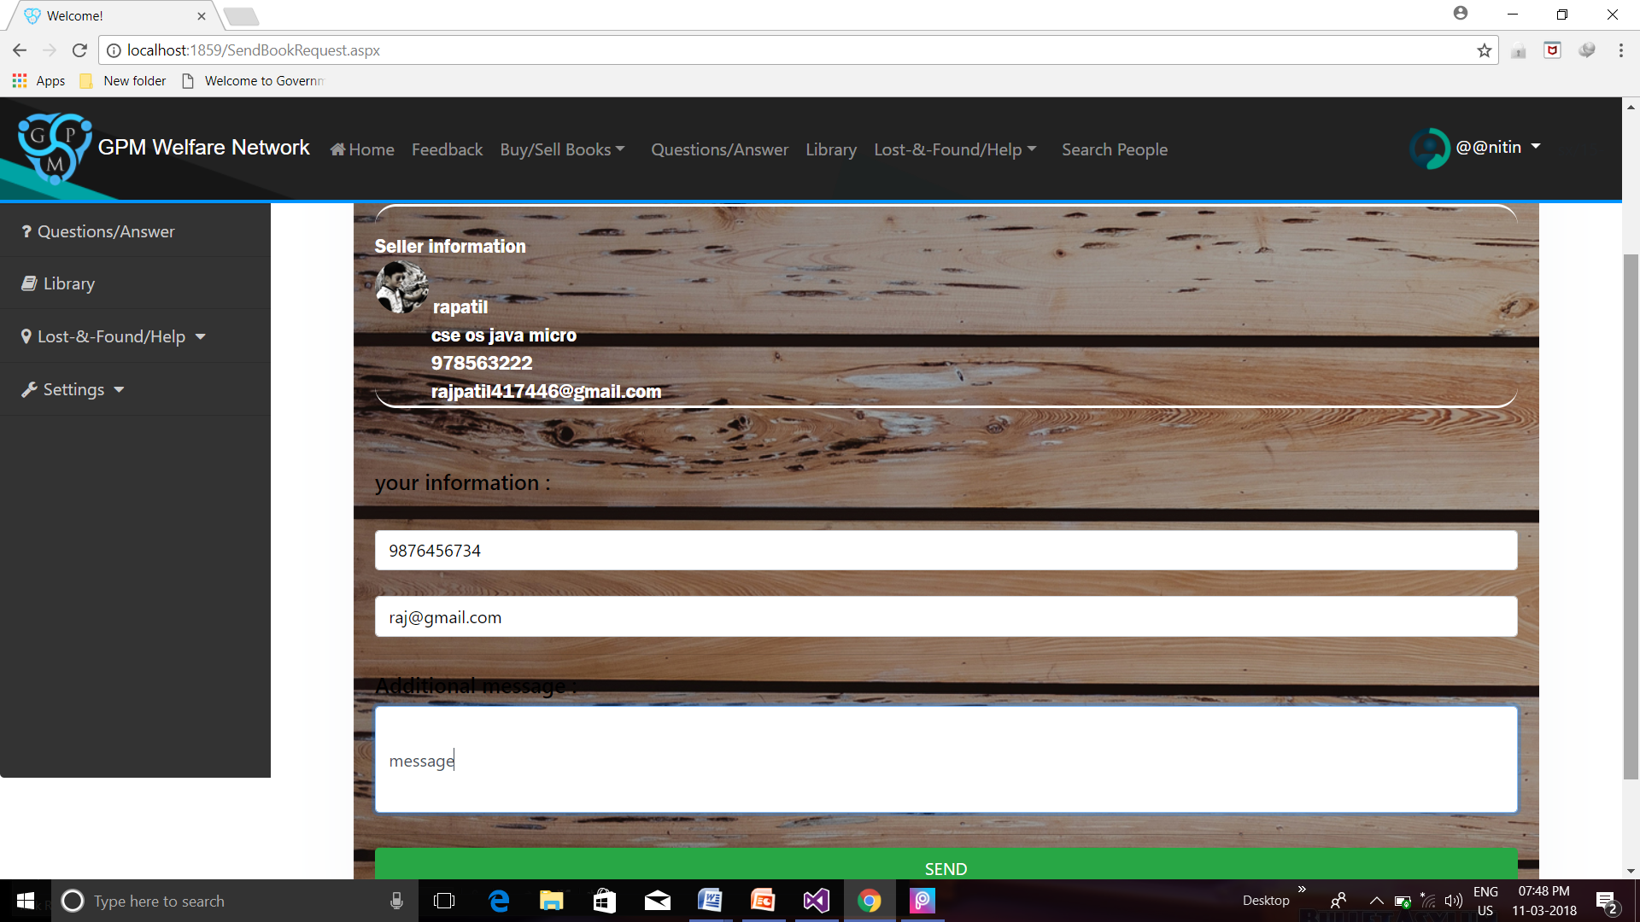

**My selling Request**

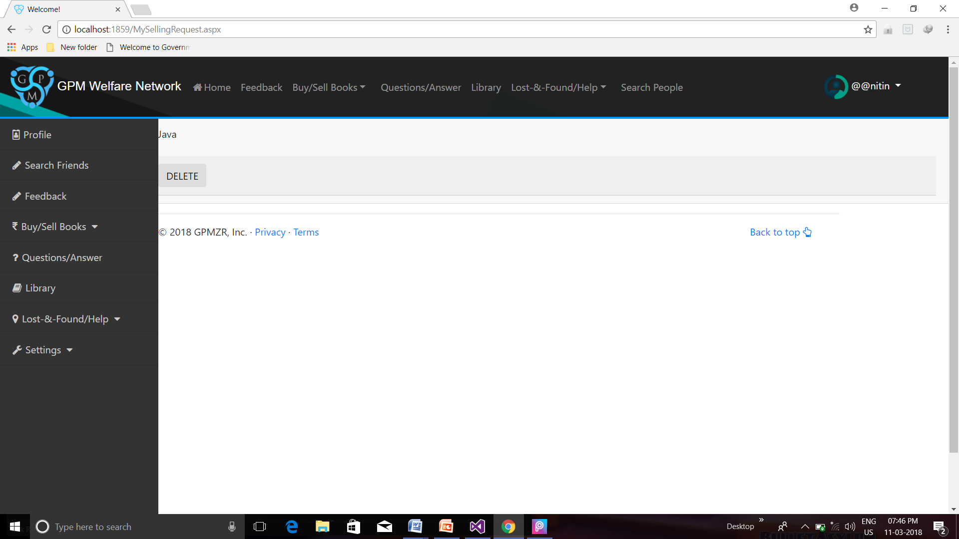

**Buyer Request**

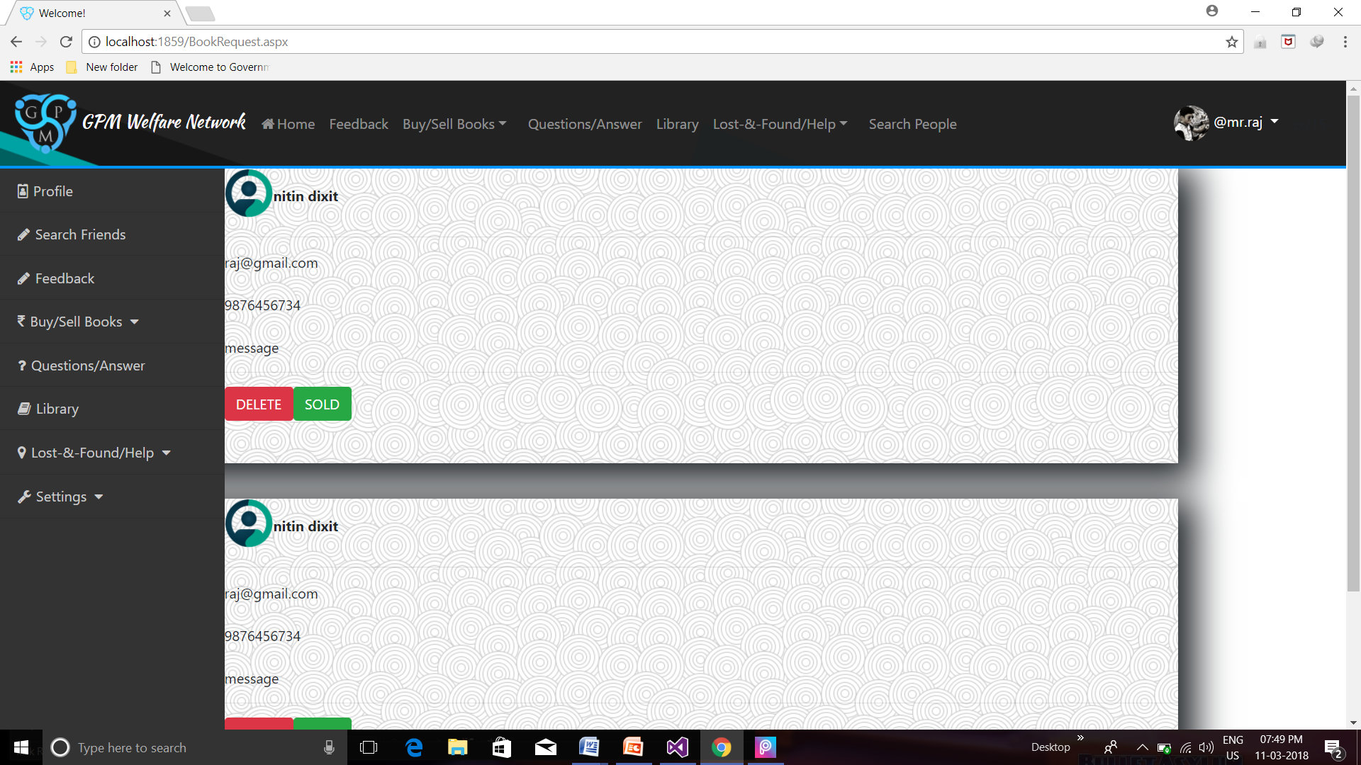

**Question And Answer module**

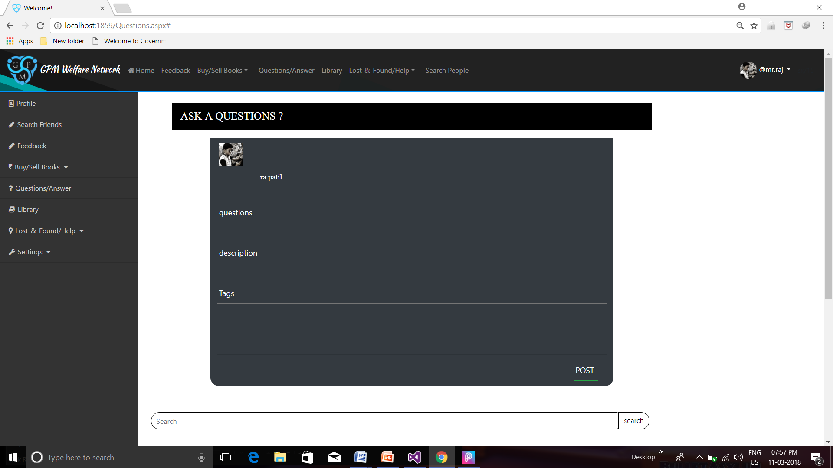

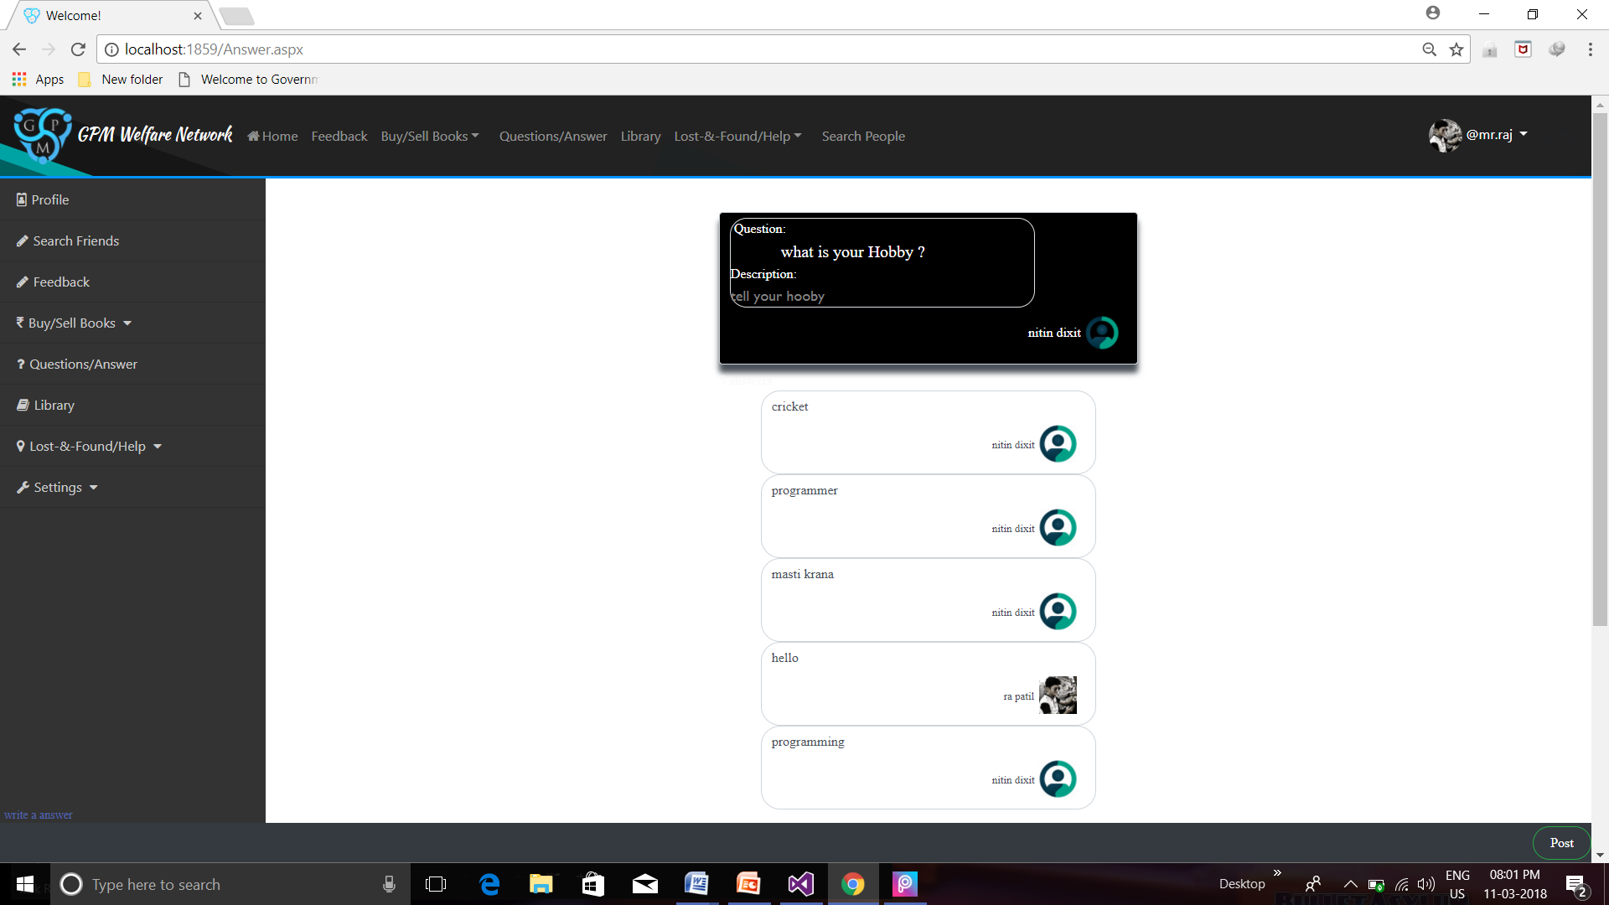

**Search Friends module**

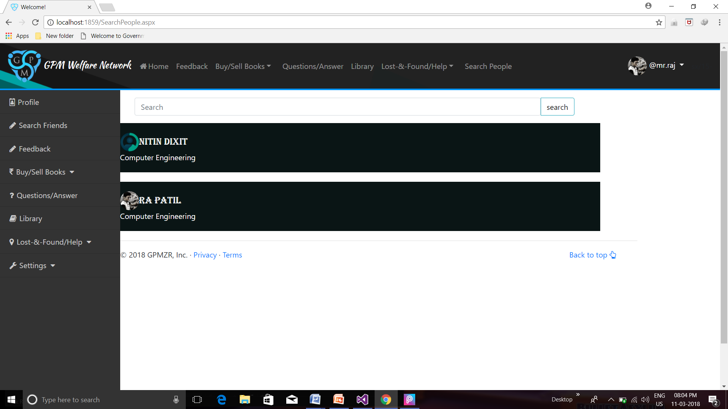

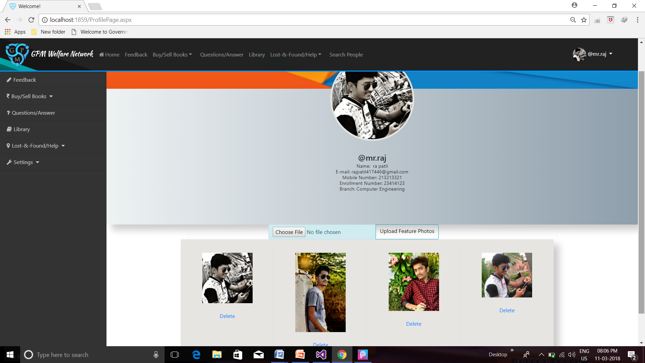

**Feedback module.**

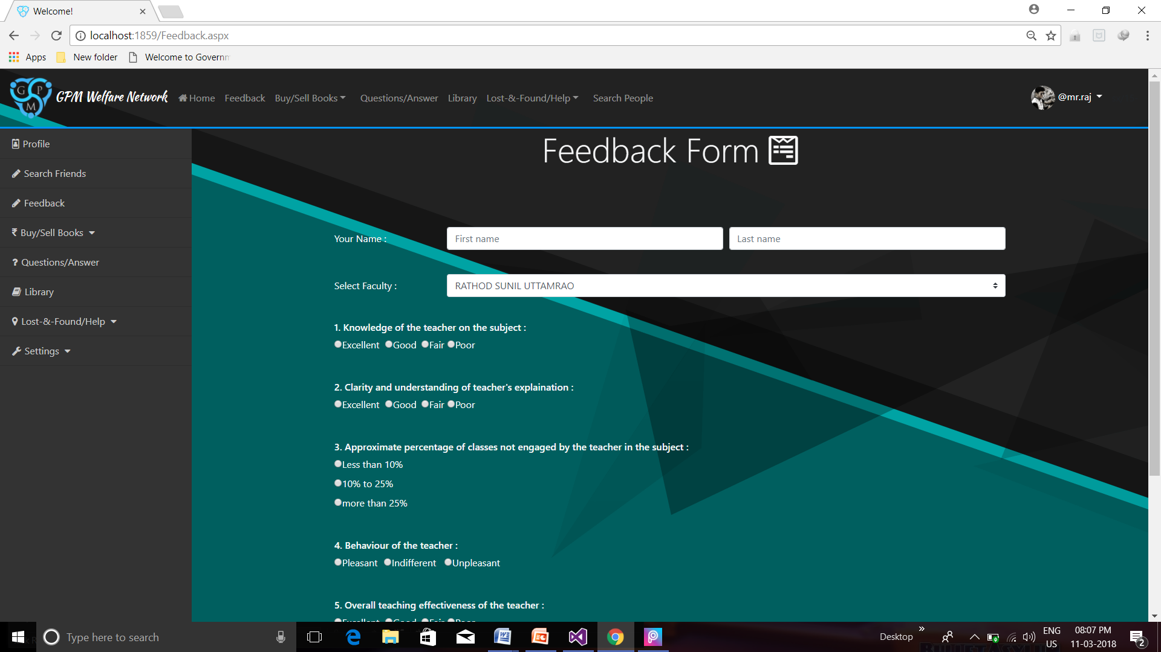

**Library module**

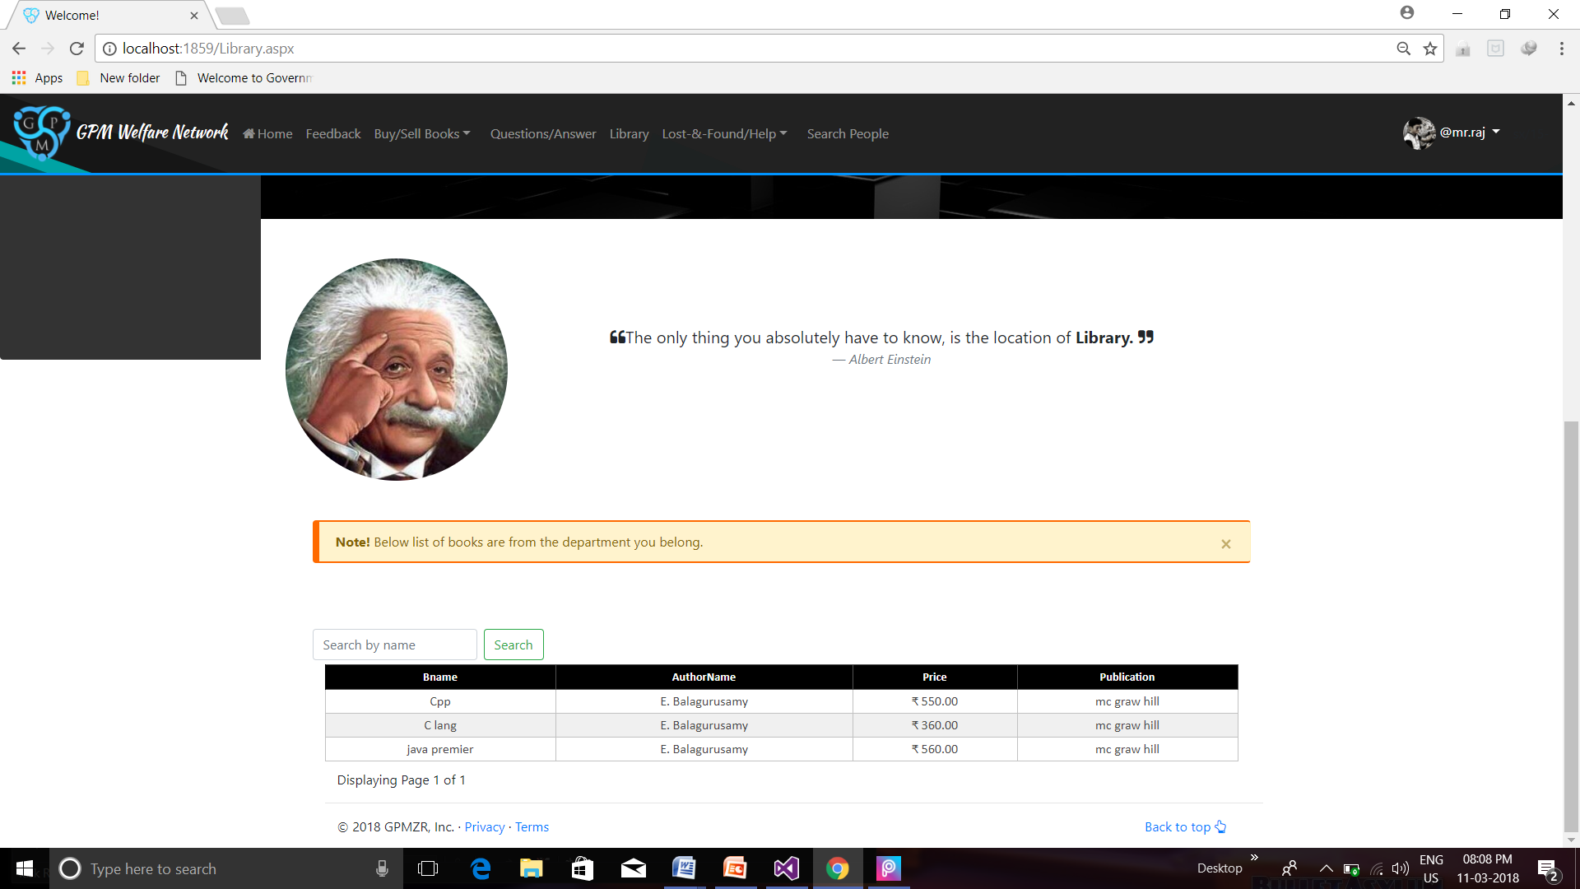

**Admin Module**

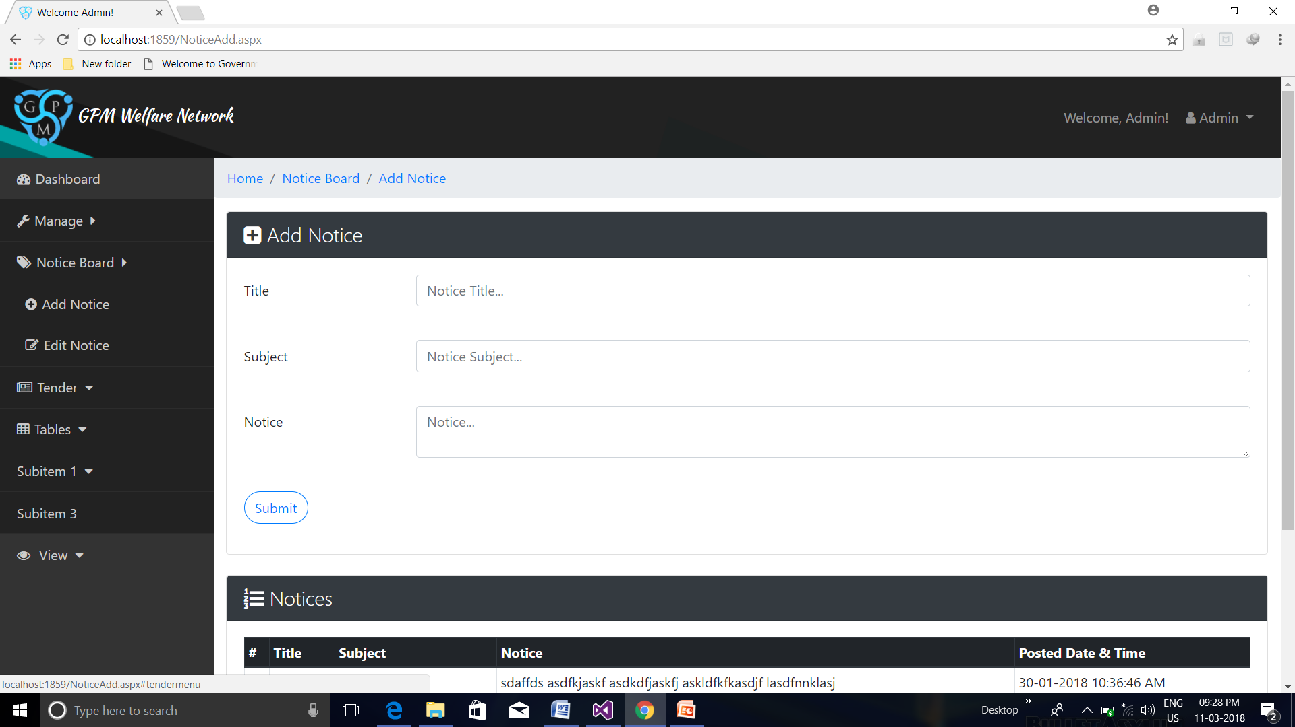

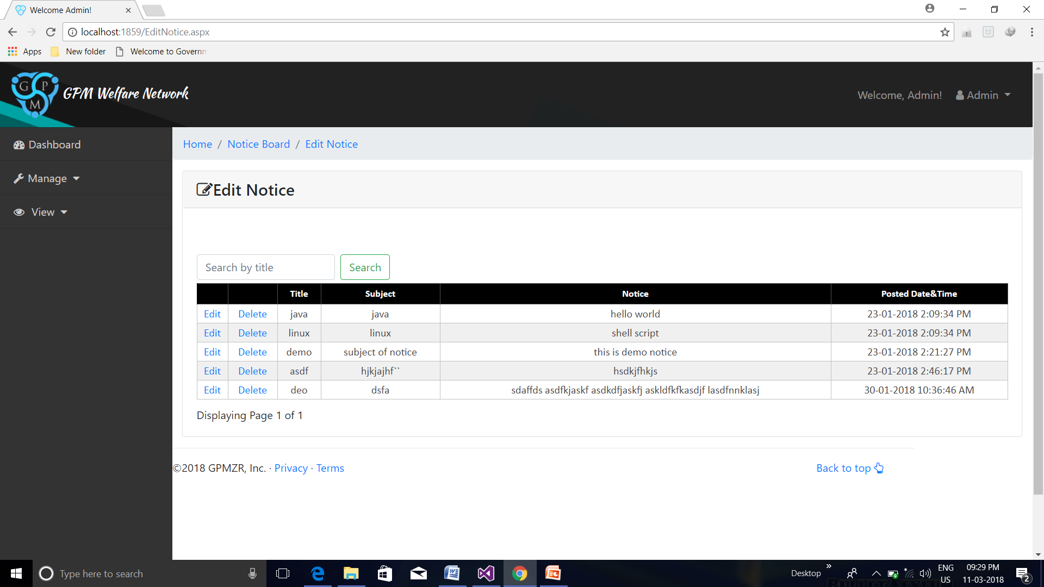

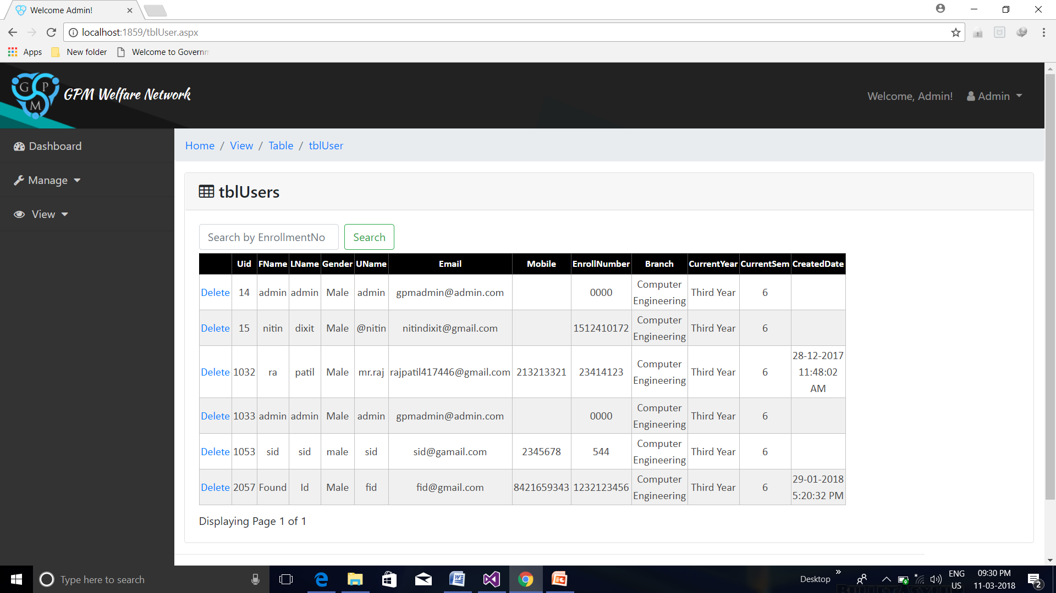

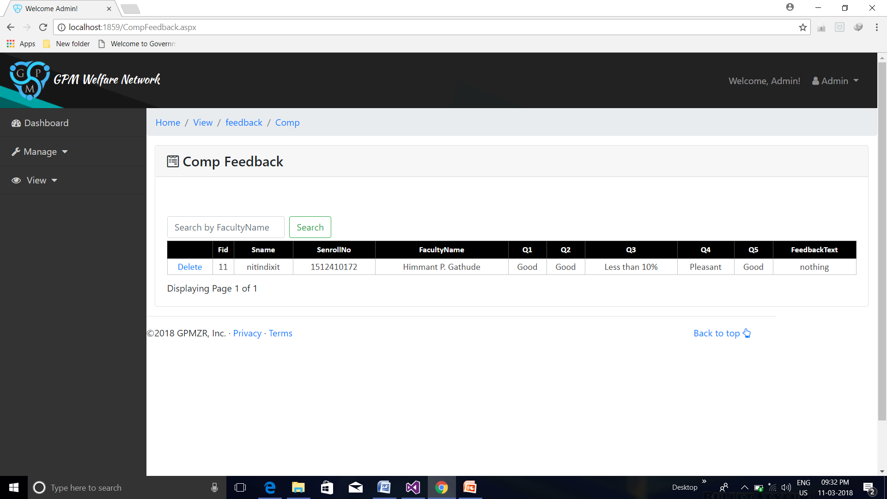

**Conclusion**

The project report entitled "GPM Welfare Network" has come to its final stage. The system has been developed with much care that it is free of errors and at the same time it is efficient and less time consuming. The important thing is that the system is robust. We have tried our level best to make the site as dynamic as possible. Also provision is provided for future developments in the system. The entire system is secured. This online system will be approved and implemented soon. The Project is successfully implemented with all the features mentioned in system requirements specification. Deployment of our application will certainly help the college to reduce unnecessary wastage of money in buying the services online at sites like wordpress etc. and our site is dynamic too which is a great advantage.

**Future Work**

* Real time Social Netwoking module would be introduced to allow member of GPM Welfare Network to chat with their friends.
* SignalR technology of Microsoft would be used for real time notification when any user sends message to another user.
* Online Test module would be introduced to conduct online examination.
* Website can be made available to be translated into different languages like Marathi, Hindi etc.
* Further, the faculty can upload the videos of their lectures on the site and students who had missed those classes can view those videos.

**References**

1. [**ASP.NET**](http://ASP.NET) **Bible - Mridula Parihar.**
2. **www.stackoverflow.com**
3. [**www.c-sharpcorner.com**](http://www.c-sharpcorner.com)
4. [**www.programmersheaven.com**](http://www.programmersheaven.com)
5. [**https://www.tutorialspoint.com**](https://www.tutorialspoint.com)
6. [**https://www.youtube.com/watch?v=3AYoipyqOkQ&list=PL6n9fhu94yhXQS_p1i-HLIftB9Y7Vnxlo**](https://www.youtube.com/watch?v=3AYoipyqOkQ&list=PL6n9fhu94yhXQS_p1i-HLIftB9Y7Vnxlo)
7. [**https://getbootstrap.com/**](https://getbootstrap.com/)
8. [**https://www.w3schools.com**](https://www.w3schools.com)
9. [**https://msdn.microsoft.com**](https://msdn.microsoft.com)
10. **asp.net-tutorials.com**